P.G. & RESEARCH DEPARTMENT OF MICROBIOLOGY
JAMAL MOHAMED COLLEGE (Autonomous)
Accredited (3rd Cycle) with ‘A’ Grade by NAAC
(Affiliated to BharathidasanUniversity)
TIRUCHIRAPPALLI – 620 020.
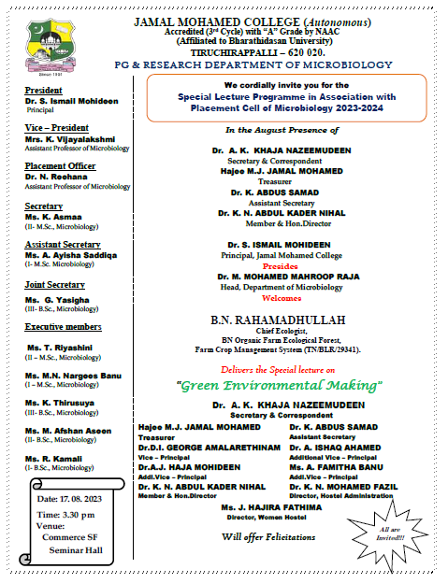

P.G. &RESEARCH DEPARTMENT OF MICROBIOLOGY
JAMAL MOHAMED COLLEGE (Autonomous)
Accredited (3rd Cycle) with ‘A’ Grade by NAAC
(Affiliated to BharathidasanUniversity)
TIRUCHIRAPPALLI – 620 020.

Special Lecture Programme in Association with
Placement Cell of Microbiology 2023-2024

The Special lecture programme in association with placement cell of microbiology was held on 17.08.2023 at 3:30 p.m. in Commerce SF Seminar Hall, Jamal Mohamed College. The programme was started with Qirath by R.Sumaya banu of I M.Sc., Microbiology. Dr. M. Mohamed Mahroop Raja, Head of the department welcomed the gathering and honoured the Resource person. A.K.Afrin of I M.Sc., Microbiology introduced the chief guest. The special invite B.N. Rahamadhullah, Chief Ecologist, BN Organic Farm Ecological Forest, Farm Crop Management System Excellence & Product Development, Tiruchirappalli- 06 delivered the special lecture on “Green Environmental Making”. He focused his topic on how to change the waste land to a fertile land, the importance of agriculture in organic farming, the role of animals and birds in soil and crop fertility. He also added his lecture on the conversion of vegetable waste and dead animals as green manure and the production of bio fertilizers. He concluded his lecture with the wide range of entrepreneurs in organic farming which was really inspired the students. The vote of thanks was proposed by Dr. N. Reehana, Assistant Professor and Placement officer of Microbiology department. Totally 180 Participants were participated from the Microbiology department. This program featured with a wide knowledge of sharing the expertise in the field of organic farming.

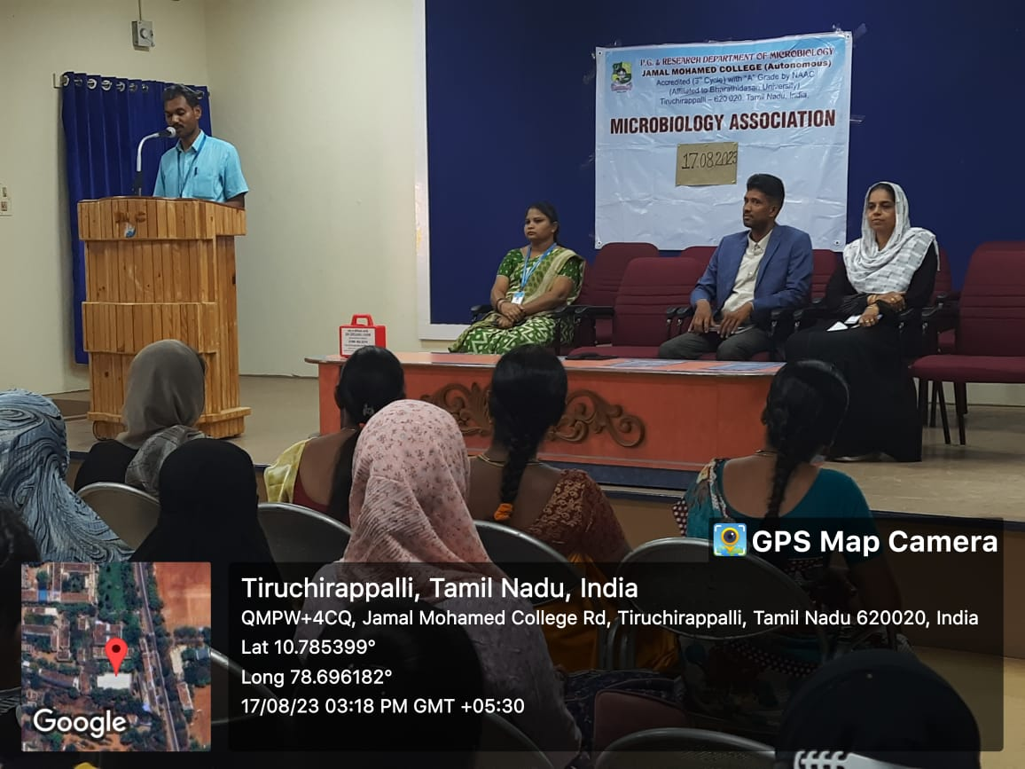

Dr. M.Mohamed Mahroop Raja, Head of Microbiology welcomed the gathering
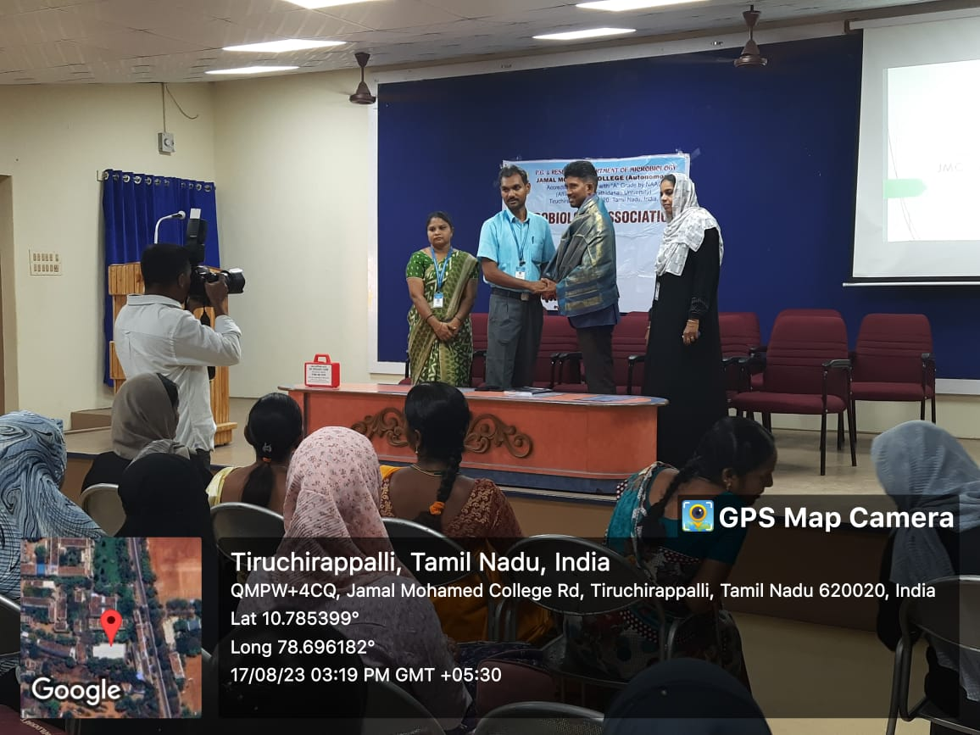

B.N. Rahamadhullah, Chief Ecologist, BN Organic Farm Ecological Forest, Tiruchirappalli delivered the Special Lecture on “Green Environmental Making”

